CSC424 Database Application Design Document

Project Name: Hero Food Delivery Service

Project Team Members: Ryan Chen, Tony Mai

Creation Date: 5/12/17
Revision History: 5/12/17

1. Introduction
This is a windows application where you can order and have your food delivered to your door step at a click of a button. We designed a user friendly interface where the customer is able to create an account and use their account to order food. This application will be built with C# and implemented with a database using MySQL.

2. Architecture Design

Our architecture design is going to be multi-layered design and part client server model. Our presentation layer is going to be our windows application form where the user can interact with the program. Our middle layer is going to be the DLL(Dynamic-Linked Library) we made to validate our customer’s input information. It verifies that the information the user inputted into our application is acceptable. Our Data layer is our database where we are going to use MySQL to keep track of every customer information. We will update the database each time the customer creates an account, change their account information, or even ordering food from our application.

3. Database Design

The data will be inputted into our windows application and then transfer the inputted information into our MySQL tables. For example, when the user creates and account we will have their username and password transferred to our login table in our database and their first and last names will be transferred to customer information. We also have another table that will be used to keep track of orders from all of our customers.

3.1 Entity-Relationship Diagram – Business Data Model
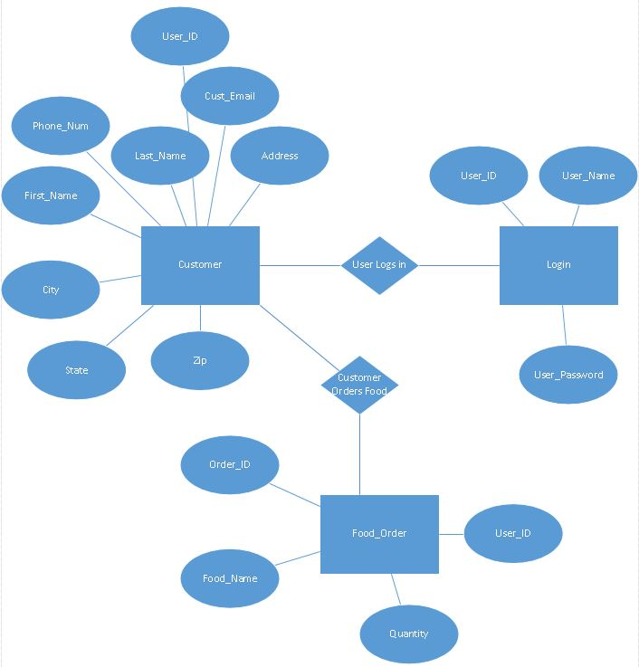

3.2 Relational Data Model

Login (User_ID, User_Name, User_Password)
Customer (User_ID, First_Name, Last_Name, Address, City, State, Zip, Phone_Num, Cust_Email)
Food_Order (Order_Id, Food_Name, Quantity, User_ID)

3.3 Logical Schemas

Login
Description | Login Information inputted by the customer
Attribute | Description | Type | Examples of values
User_ID | Id of a user | Char | U1
User_Name | Username of the customer | Varchar | Administrator
User_Password | Password of the customer | Char | Password
Primary Key | User_ID

Foreign Keys
Sample SQL Code | Select * from login

Customer
Description | This table describes customer’s information
Attribute | Description | Type | Examples of values
User_ID | Id of the customer | Char | U1
First_Name | First name of customer | Char | John
Last_Name | Last name of customer | Char | Adams
Address | Address of customer | Char | 160 Adams St.
City | City of customer | Char | Brooklyn
State | State of customer | Char | NY
Zip | Zip code of customer | Char | 11220
Phone_Num | Phone number of customer | Char | 7185524210
Cust_Email | Customer Email | Varchar | johnadams@gmail.com
Primary Key | User_ID
Foreign Keys | User_ID
Sample SQL Code | Select * from customer

Food_Order
Description | Keeps track of every customer orders
Attribute | Description | Type | Examples of values
Order_ID | Order ID of an order | Char | O12
Food_Name | Name of the food ordered | Char | Chicken Sandwich
Quantity | Number of food ordered | Char | 12
User_ID | ID of customer order | Char | U1
Primary Key | Order_ID
Foreign Keys | User_ID
Sample SQL Code | Select * from food_order

4. Graphical User Interface
Login:
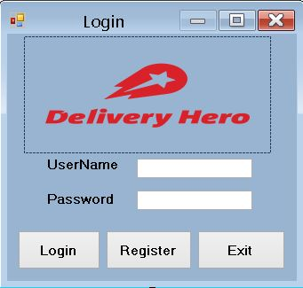
Register:
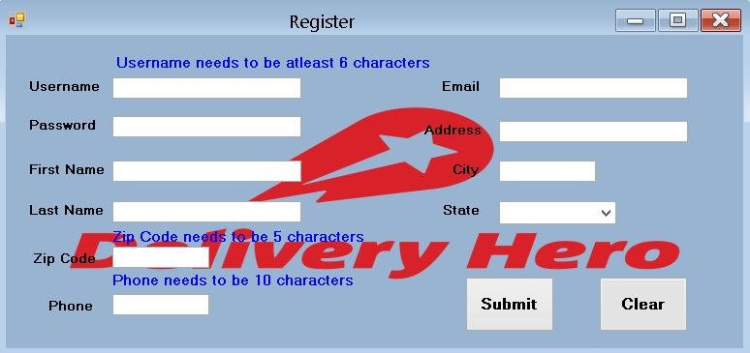
Order History:
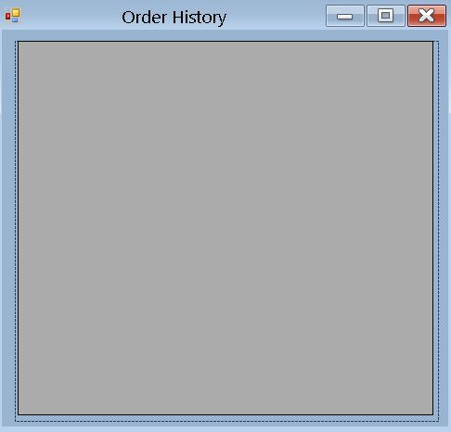

Selection:
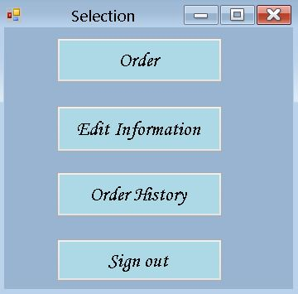

Order:
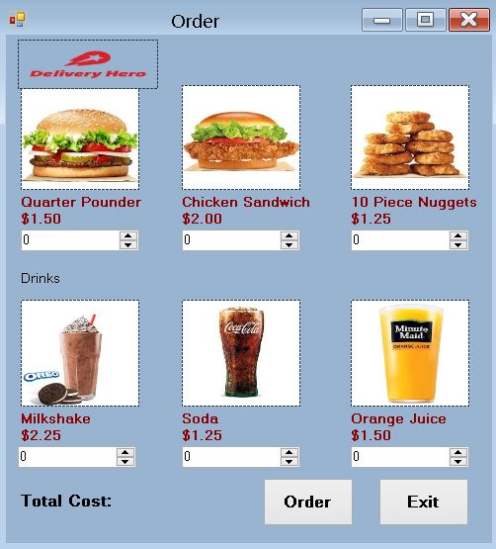

Edit Information:
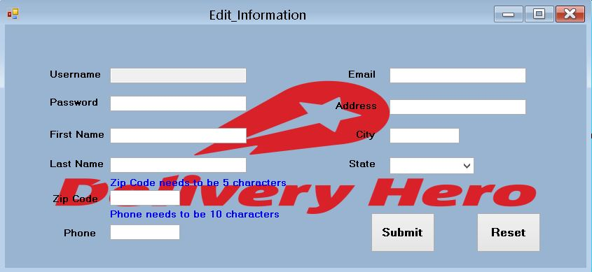

5. References
- https://www.w3schools.com/
- http://www.cs.fsu.edu/~lacher/courses/COP3331/sdd.html

